1. Pinned memory
Pinned memory is allocated and freed with specific functions implemented by CUDA. We use cudaHostAlloc() to assign write-combined option to pinned memory. These functions work with the host operating system to allocate page-locked memory and map it for Direct Memory Access(DMA) by devices. The host operating system use kernel function get_user_pages() for page-locked memory. CUDA keeps track of pinned memory of itself and accelerates memory copies that involve host pointer allocated with cudaHostAlloc(). And the asynchronous memcpy functions need pinned memory. Pinned memory can reach maximum bandwidth because of DMA. But allocating pinned memory is expensive because it involves a considerable amount of work for the host and reduces the amount of physical memory available to the operating system and other programs.

2. Double buffering
Because the device operates autonomously and can access the host memory without any operation system, only pinned memory is available for asynchronous memcpy. The device cannot access pageable memory directly, the driver implements pageable memcpy with a pair of pinned buffers that are allocated with the CUDA context. To perform a host device memcpy, the driver first copies to one pinned buffer, then sends the request of a DMA operation to read that data with the device. While the device starts processing that request, driver copies another data in the other pinned buffer. The host and device keep flip-flopping between pinned buffers, with synchronization, until the device performs the final memcpy. And the host also naturally pages in any cached pages while the data is being copied.
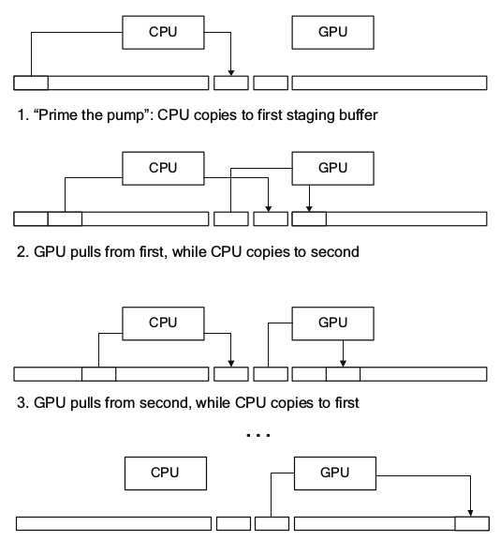

But this method can cause relatively slow data transfer speed if the speed of memcpy from the host to the buffer is slower than the speed of memcpy from the buffer to the device because there are significant delays among memcpys from the buffer to the device.
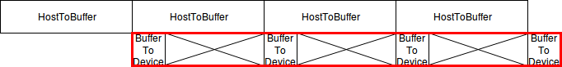

3. Write-combined memory
Write-combined memory or uncacheable write-combining memory was created to allow the host to write to device frame buffers fast and no pollution of the host cache. For CUDA, write-combined memory can be allocated by calling cudaHostAlloc() with the cudaHostWriteCombined flag. Besides setting the page table entries to bypass the host caches, write-combined memory also is note snooped during PCI Express bus transfers. Reading WC memory with the host is 6x slower than normal memory but this problem is solved by using MOVNTDQA instruction that is new with SSE4.1. NVIDIA implemented memcpy function using MOVNIDQA instruction to accelerate memcpy from WC memory to normal memory for device host transfer of gdrcopy(A low-latency GPU memory copy library based on NVIDIA GPUDirect RDMA technology)

